Leo’s Biography (as at March 2017)
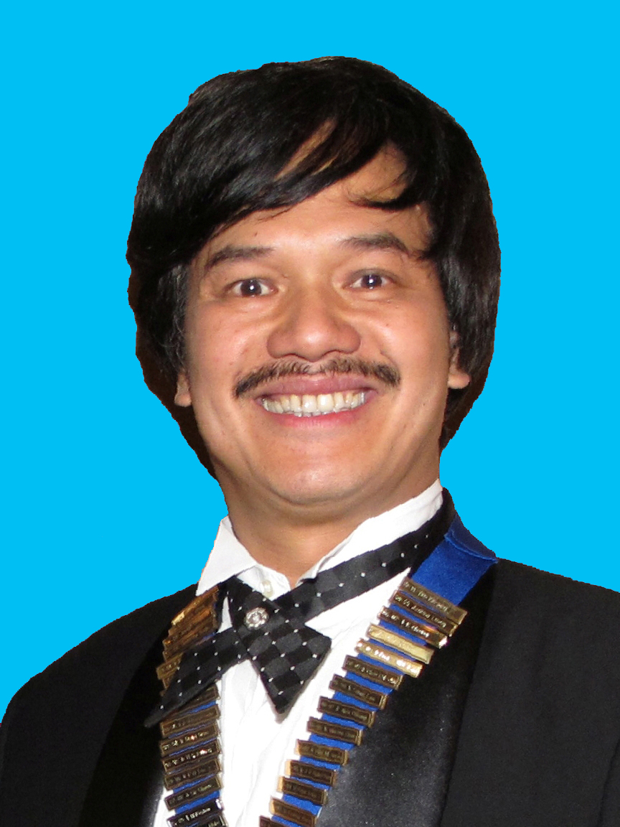

Ir Dr Leo Kwok Kee LEUNG 梁國基 博士 工程師

Aged 58, it was 34 years ago when Leo graduated from Sunderland with a (CNAA) Bachelor of Science Degree in Civil Engineering. He was at Top of the Class and the only student who was awarded First Class Honour in his year. As such, he was further awarded by the Institution of Civil Engineers for his outstanding undergraduate performance in 1983.

Since he undertook a Thin-Sandwich Degree course at Sunderland, he spent two half-years working in Newcastle for the Tyne and Wear Metro project during 1980 and 1981, in the UK.

Upon his graduation, he was in fact offered by the Civil Engineering Department as well as the Science and Engineering Research Council to undertake a PhD research at Sunderland, but he decided he would like to first apply his learned knowledge in the industry, before launching into further academic study and research. As such he started his working career from 1983.

After his graduation, throughout his working life, he worked in Singapore, Europe, Africa, and South East Asia, and had acquired a wide range of design and construction experiences in highways, bridges, buildings, dams and tunnel structures. When he was undertaking a Seismological Assessment of the Dead Sea region for a project in River Jordon, to assess if River Jordon could be used as a Reservoir to adequately supply water for the whole region, he was awarded a British Public Works Congress’ Manzoni Award in 1990 to study at Imperial College and then graduated from Imperial College with a Master of Science degree with Distinction in Earthquake Engineering and Structural Dynamics in 1991. Four such projects worth mentioning in his early career are the Mass Rapid Transit System (MRT) in Singapore, the Central Bank of Kenya in Nairobi, and the Third Nairobi Water Supply Project in Kenya, and the Great Man-made River (water supply) Project through the Sahara Desert in Libya.

Having gained his initial precious experiences around the world, he joined the Hopewell Group in Hong Kong (in 1993) to further apply his learned skills and technology and then subsequently take charge of some very exciting infrastructural projects in the fastest growing economy in the world, China.

During his time with Hopewell, he has completed hundreds of kilometers of Superhighways, many Power Stations, as well as assisting Hopewell Group Chairman, Sir Gordon YS Wu (KCMG) to have successfully promoted the implementation of the Hong Kong-Zhuhai-Macao Bridge; a 41.8 km long dual-3 lane, a total of 6-lane vehicular Bridge-Tunnel Fixed Link across the Pearl River Estuary, which is the Largest Scale Longest Bridge-Tunnel in the world, now it is being undertaken by the Governments of Hong Kong, Macao and Guangdong Province together collectively.

In 2004, Leo was awarded the PRC National Class 1 Registered Structural Engineers qualification, and then received the full registration qualification in 2012; there are only about 180 such Engineers from Hong Kong who have received such full registration qualification.

He served as Mentors to some university students as well as on some Advisory Committees in different Departments. He was also Committee Members to a number of Professional Institutions and was the Chairman of the Civil Division (2011-2012) of the Hong Kong Institution of Engineers (“HKIE”), and a Council Member of the HKIE (since 2012 till present time). He was also the Chairman of the Hong Kong Branch of the Chartered Institution of Highways and Transportation (2006-2007).

Owing to his positive and long standing services to the Engineering Community in Hong Kong, he was elected by his peer engineers, as an Election Committee Member by the Engineering Subsector for the nomination and election of the Chief Executive of HKSAR in 2012 for a 5-year term.

Within Hopewell, he was appointed as an Executive Director of HHI and responsible for the planning, design, engineering and construction of Highway Infrastructural projects within HHI from 2003 to 2009. In October 2009, he was promoted as an Executive Director of the Hopewell Holdings Limited.

In 2016, He was further awarded an Honorary Doctorate of Technology from his alma mater, the University of Sunderland (England).

Ir Dr Leo Kwok Kee LEUNG 梁國基 博士 工程師
BSc MSc DIC HonDTech CEng EurIng FHKIE FIStructE FICE
FCIHT FHKIHT FIIM FHKIoD CMILT ACIArb
PRC National Class I Registered Structural Engineer (Qualified)

Optional Information:-

Other Public Services
* 2004 Subject Specialist of Hong Kong Council for Academic Accreditation e.g. Member of a Panel to validate a Bachelor Degree by Chu Hai College

* 2004 – 2007 Member of Noise Control Appeal Board Panel, HKSAR Government

* 2005 – 2006 Member of the Infrastructure Development Advisory Committee for the Hong Kong Trade Development Council

* 2005 – 2007 Member of the Department Advisory Committee for the Department of Building and Construction, City University of Hong Kong

* 2005 – 2007 Honorary Associate of School of Business, Hong Kong Baptist University

* 2009 – 2010 Mentor of Hong Kong Polytechnic University, Department of Mechanical Engineering

* 2011 Election Committee Member (Engineering Subsector) for the Hong Kong Chief Executive election, 2012

* 2013 – 2014 Management Committee of The Centre for Infrastructure and Construction Industry Development (CICID) at The University of Hong Kong

* Present Member of Appeal Board (Hotel & Guesthouse Accommodation), Appeal Board (Clubs Safety of Premises) and Appeal Board (Bed space Apartments), HKSAR Government

* Present Member of Building Department (BD)-Technical Committee for the Code of Practice for Foundations, HKSAR Government

