For Immediate Release

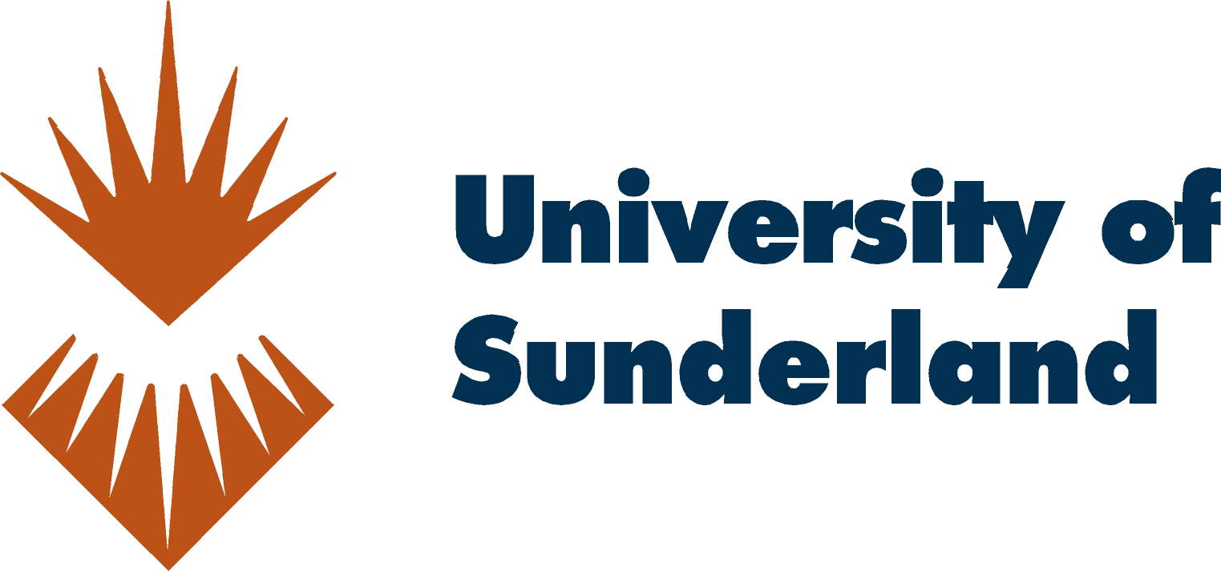

The University of Sunderland Offers Higher Education Programmes
for Hong Kongers with Launch of First Asia Campus
Top Five UK Transnational Education Provider Expands its Footprint to Asia
with Sound Understanding of Employer Needs in the Market

Hong Kong, March 2, 2017 – The University of Sunderland opened its first campus in Asia today, providing 1,000 placements for students to attain a globally recognised degree from a UK university, right in the heart of Central, Hong Kong. Offering both undergraduate and postgraduate programmes, the University of Sunderland in Hong Kong aims to broaden the path for students to succeed by offering a new curriculum incorporating employability skills, to create the next generation of career ready graduates.

With a dedicated campus established in the heart of Central, the University of Sunderland is introducing its highly successful ‘career ready’ approach to the Hong Kong market. This new approach is geared to building the success of the next generation of graduates, arming them with the right balance of academic knowledge, work relevant skills and real-world experience. With this Asia campus, students now have a three-campus offering for a broader educational experience – Sunderland, London and Hong Kong.

Vice Chancellor, Ms Shirley Atkinson said, “We are very proud of our holistic curriculum - 94% of Sunderland’s graduates gain employment or pursue further study within six months of graduating. All of this is possible with our employability-focussed programme ‘to produce ‘career ready’ graduates, which provides a tailored and industry-centric approach to help graduates acquire the skills much sought-after in the work place.” She added, “We want our graduates to become adaptive creative thinkers with the personal attributes to become the leaders and tomorrow makers of societies and economies in this era.”

Its newest offering for DSE graduates is the three years full time Bachelor’s degree with honours. Students can obtain a globally recognised degree from a UK University with honours and graduate one year ahead of their peers in Hong Kong. There is also a four year option with an embedded foundation year. Top Up degrees and postgraduate programmes are available to working professionals for study in the evenings and on weekends to balance work and study life.

The University of Sunderland’s employability-focussed programme ‘Sunderland Futures’ offers innovative support initiatives, such as real-world professional opportunities, giving students the skills to support progression to employment; in-company project work; mentoring delivered by professionals who provide knowledge and experience; opportunities for students to develop their own professional networks and leadership programmes. These are delivered through masterclasses, employability integrated modules, interview assessments and other career support services.

This expansion has increased The University of Sunderland’s footprint across the globe - Sunderland, London and now Hong Kong. Students who are based here in the Asia campus can opt to study a semester or two in the UK to broaden their learning experience. With this three-campus offering, students can gain valued networking opportunities and hone international knowledge and perspectives.

No stranger to Asia, The University of Sunderland has had longstanding success for the past 20 years, having partnered with HKU Space and Hong Kong College of Technology. At present, there are over 5,700 alumni in Hong Kong. The University of Sunderland is recognised by the Hong Kong Education Bureau, and will be commencing the intake for its new BA (Hons) Business and Management three and four year degree programmes in October 2017.

For more information on The University of Sunderland, please visit the website https://www.sunderland.edu.hk/

###

Photos

For high resolution images, please download from: https://ogilvy.egnyte.com/dl/f8tLpRY02R

About the University of Sunderland

The University of Sunderland has a rich heritage that spans more than 100 years. We have a strong worldwide reputation for delivering high quality education that leads to globally-recognised qualifications. In 2014, the University was recognised as one of the top 5 providers of transnational education in the UK – developing from the delivery of our programmes with partners abroad. We work with 28 partners across the world in countries or regions including Hong Kong, Malaysia, Singapore and Vietnam.

In addition to the UK locations in Sunderland and London, the University of Sunderland offers a unique opportunity to study for a globally-recognised qualification in the heart of Hong Kong’s vibrant business and financial district. Since 2004, the University of Sunderland in Hong Kong (formerly name RDI) has been delivering transnational undergraduate and postgraduate academic programmes in Hong Kong, preparing our graduates with the relevant employment skills and globally-recognised qualifications employers demand.

###

Media Contacts
Ogilvy Public Relations
Daphne Li  Tel.: +852 2884 8227 / 9777 0842  Email: daphne.li@ogilvy.com | Rouhui Wong  Tel.: +852 2884 8908 / 6857 8913  Email: rouhui.wong@ogilvy.com

The University of Sunderland in Hong Kong
Sandra Tong
Tel.: +852 2978 5016
Email: sandra.tong@sunderland.edu.hk
Appendix

University of Sunderland Key Information
- Established: 1901
- Chancellor: Steve Cram CBE
- Vice-Chancellor: Shirley Atkinson
- Students: 20,000 from 90 nationalities
- Campuses: Sunderland; London; Hong Kong
- Alumni: 130,000

Accolades and Achievements
- 94% of graduates in work or further study within six months of graduating
- 10 areas of ‘world-leading’ research (REF)
- 80% of alumni say their time at Sunderland has been life-changing
- Commended by the Quality Assurance Agency for enhancing student learning opportunities
- Top 20 in the world for quality of lectures, careers support and student advice (I Graduate)
- Highest Climber in The Guardian League Tables 2017 - The Guardian
- Shortlisted for Outstanding Employer Engagement – three years running (Times Higher) 300 study abroad opportunities

Academic Strengths
- Advanced Manufacturing and Engineering
- Computer Science and Big Data
- Health Sciences
- Education and Society
- Business and Law
- Arts and Creative Industries

