Professor Michael Young

Deputy Vice-Chancellor
University of Sunderland
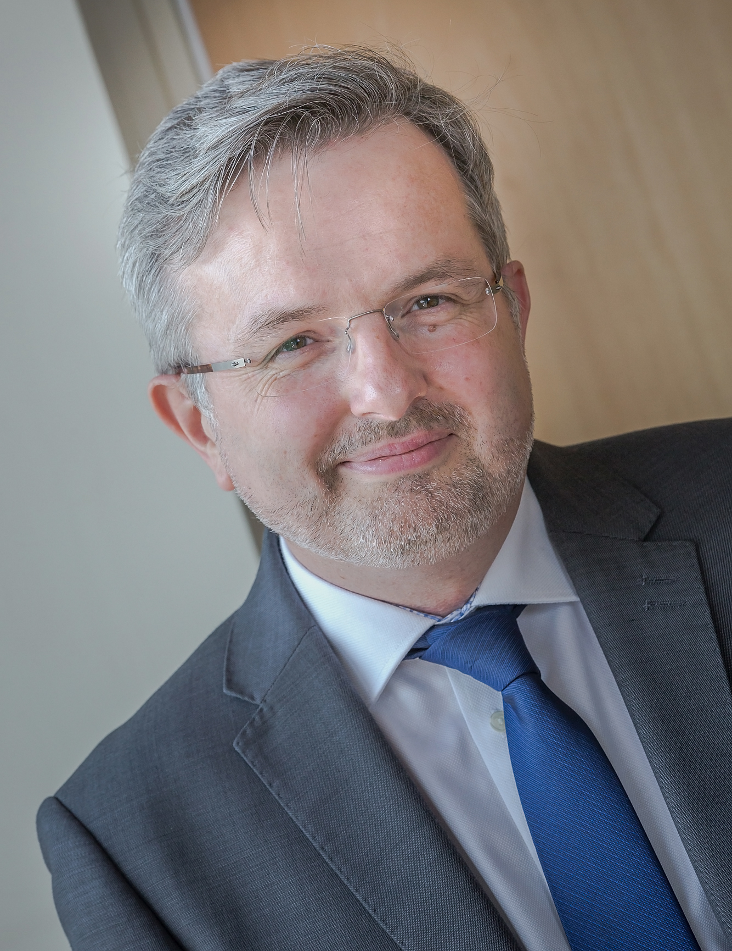

Professor Young is responsible for the University’s academic portfolio, including the delivery and quality of programmes, teaching and learning and research. He is also responsibility for students’ academic experience and achievement, as well as ensuring teaching and research staff are supported and developed to achieve excellent outcome.
He was formerly Pro Vice-Chancellor (Teaching and Learning) at De Montfort University. Pro-Warden (Students and Learning Development) at Goldsmiths, University of London and the Head of Music.
He is a Professor of Music Computing with interests in composition, artificial intelligence & music, improvisation and generative media. He is co-founder of the Live Algorithms for Music network.

